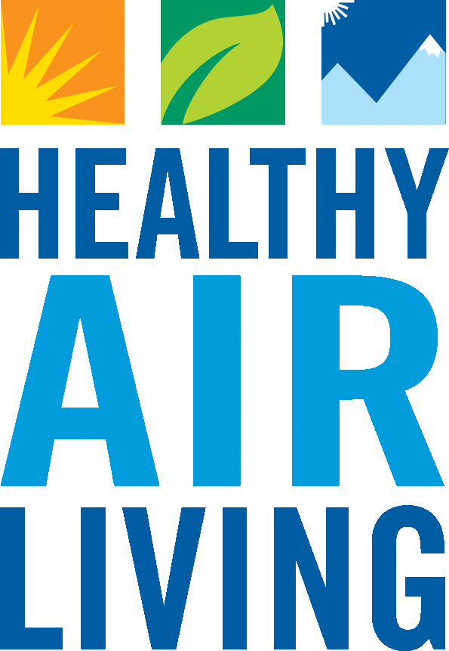San Joaquin Valley Air Pollution Control District
www.valleyair.org

Rule 3110 Small Business Certification
Please complete one form for each District Facility ID

For facilities that meet the Small Business criteria as outlined below, the Rule 3110 (Air Toxics Fees) fees are capped at a flat rate of $350 per year. Note, facilities may already be subject to a lower fee based on another fee category in the rule.

Facility Name: | District Facility ID #:
Facility Mailing Address:

Facility Location Address:

Title 17 of the California Code of Regulations Section 90704 provides for a cap on the total annual air toxic fees, including District and State fees, charged for small businesses. To qualify for the small business cap, a company official must complete and submit the following statement certifying the business meets all of the following criteria as specified in the regulation:
- I hereby certify that the facility named above is independently owned and operated.
- I hereby certify that the facility named above had 10 or fewer (annual full-time equivalence) employees in the preceding year.
- I hereby certify that the facility named above had total annual gross receipts of less than $1,000,000 in the preceding year.
- I hereby certify that the total annual gross receipts for the California operations that the facility named above is part of, were less than $5,000,000 in the preceding year.

Facility Contact Name (Print): | Facility Contact Phone #:
Facility Responsible Official Name (Print): | Title of Responsible Official:
Signature of Responsible Official: | Date:

Please mail this form to:

Carol Flores - SJVAPCD
1990 E. Gettysburg Ave.
Fresno, CA 93726

Or

E-mail to: hotspots@valleyair.org

